Part 1

Q1 Sine Wave

(2)

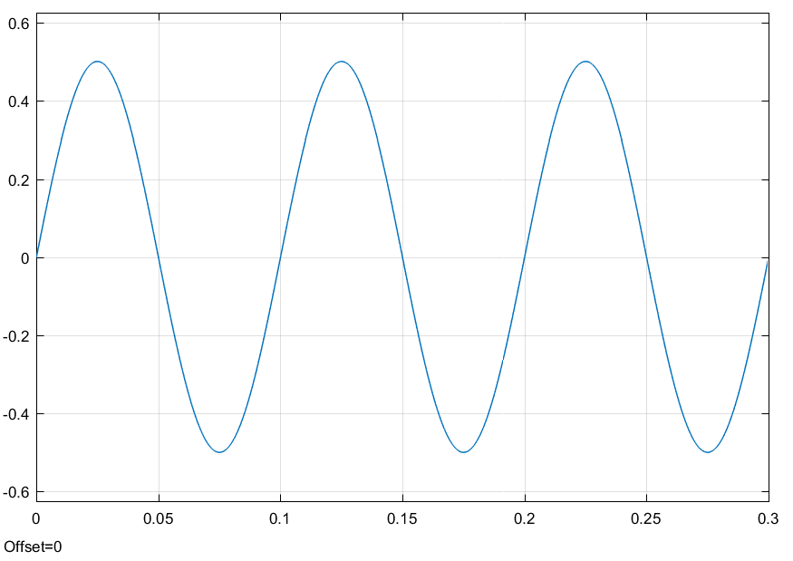

(3)

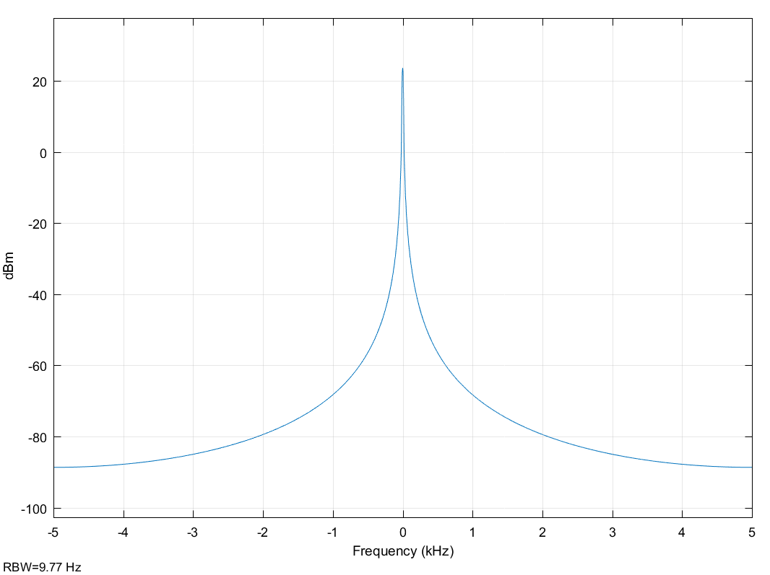

Amplitude = 0.5

Period = 0.1 s

Frequency = 10 Hz

Q2 Triangular Wave

(4)

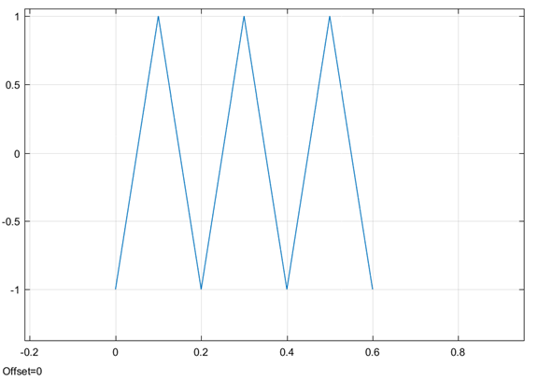

(5)

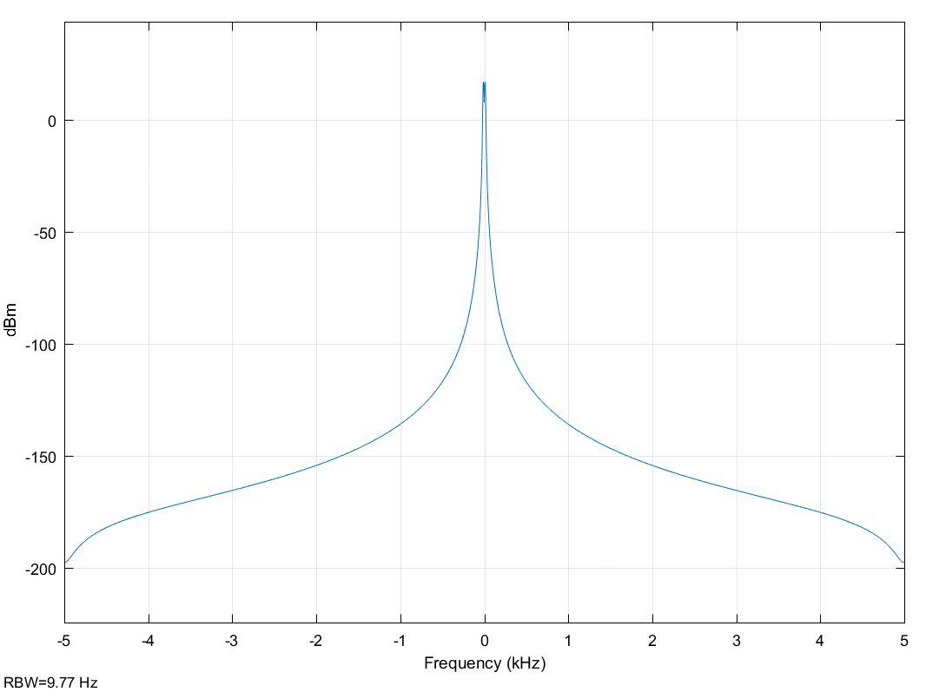

Amplitude = 1

Period = 0.2 s

Frequency = 5 Hz

Q3 Pulse Wave 50 %

(6)

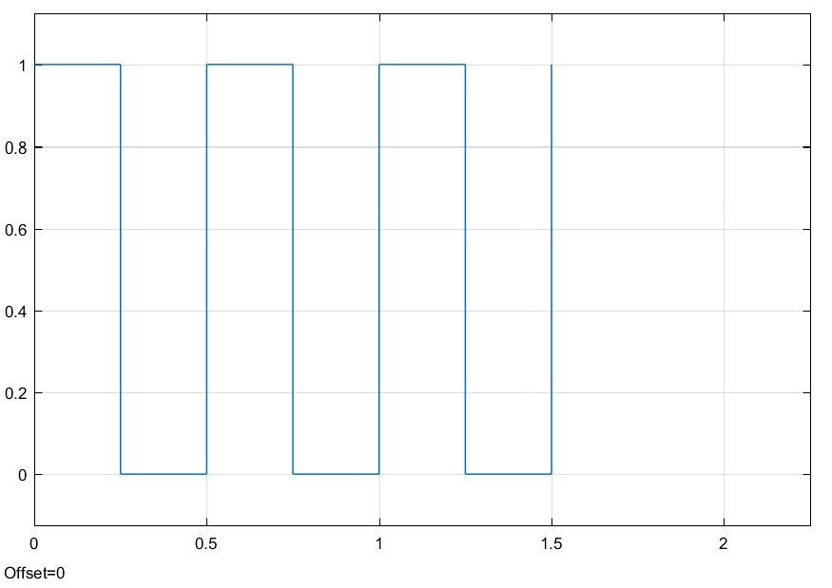

(7)

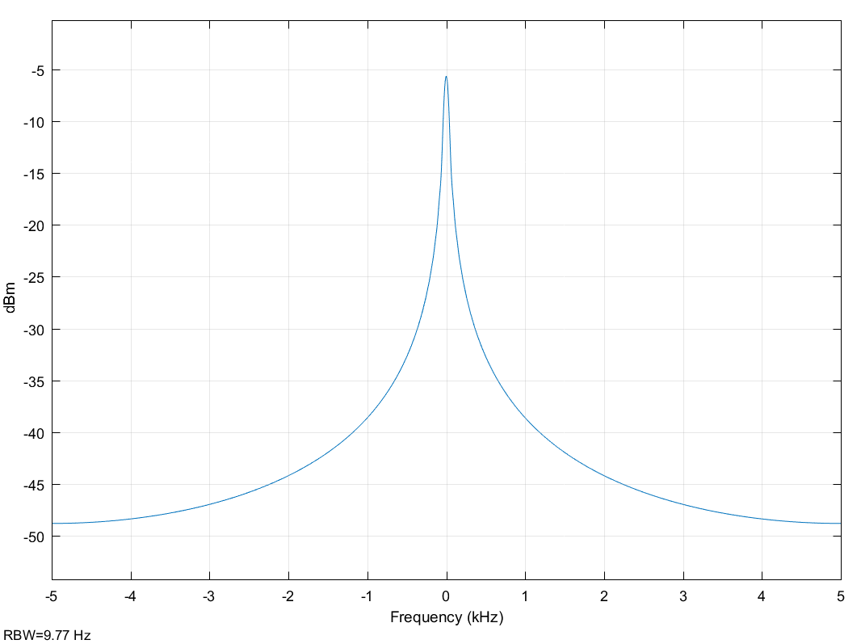

Amplitude = 1, based on pulse height

Period = 0.5 s

Frequency = 2 Hz

Q4 Pulse Wave 20%

(8)

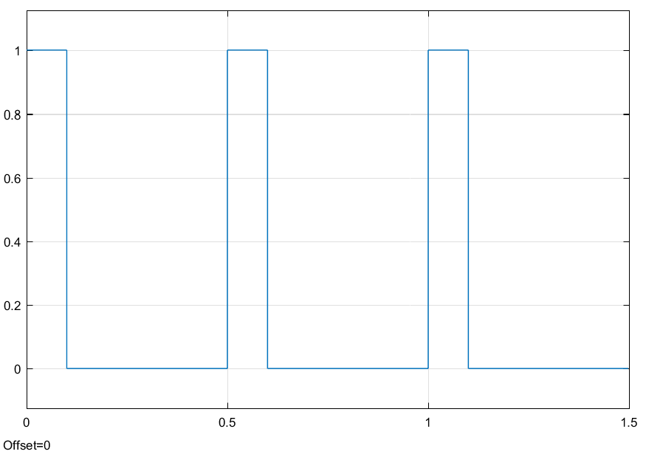

(9)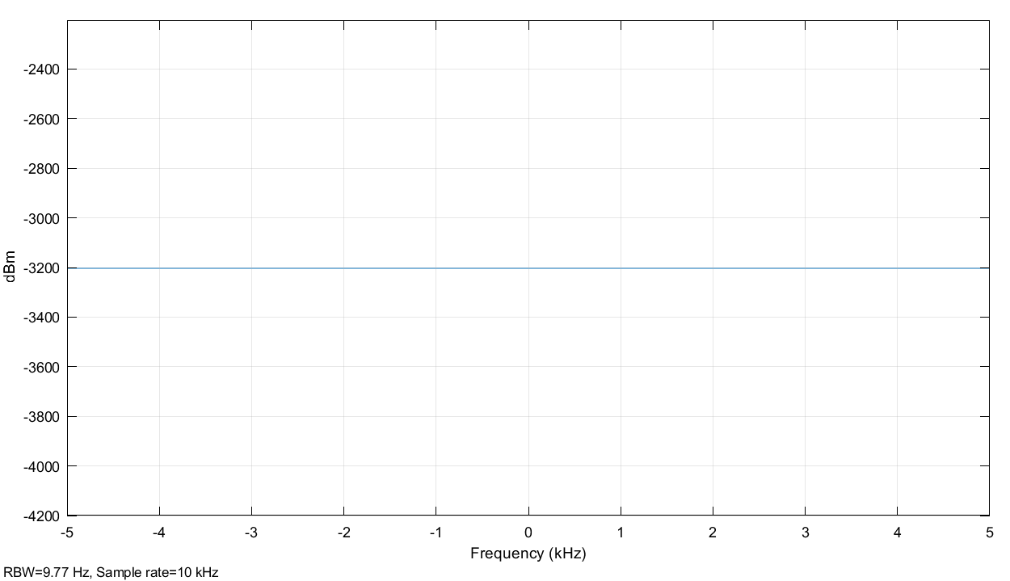

Amplitude = 1, based on pulse height

Period = 0.5 s

Frequency = 2 Hz

Q5 Sum of Signals, three sine waves

(10)

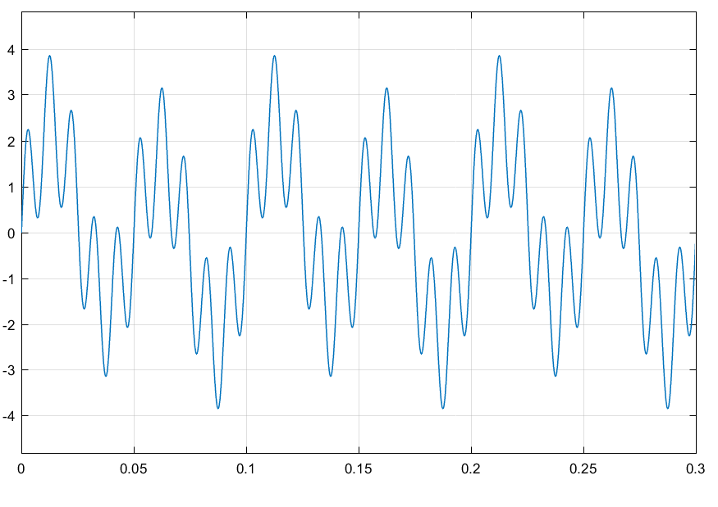

(11)

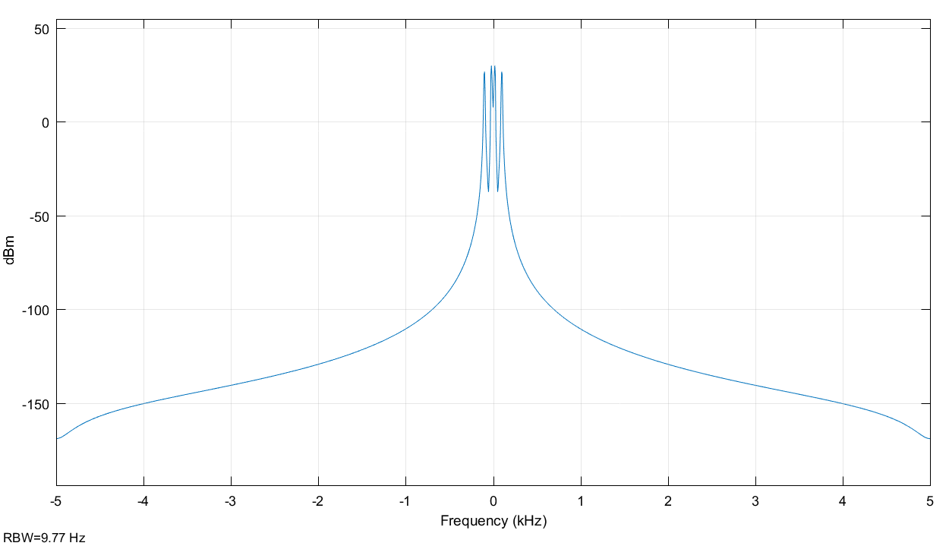

Amplitude = 3.85

Period = 0.1 s

Frequency = 10 Hz

Q6

(13)

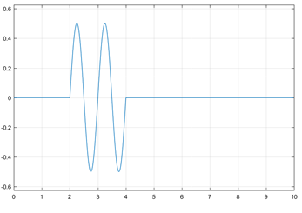

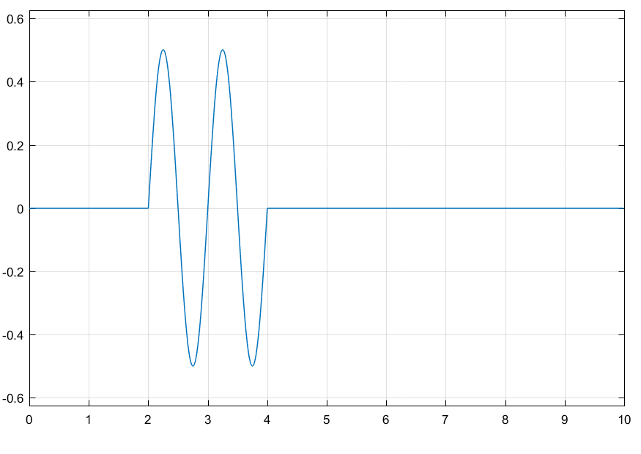

Comments on Periodicity:

Q7

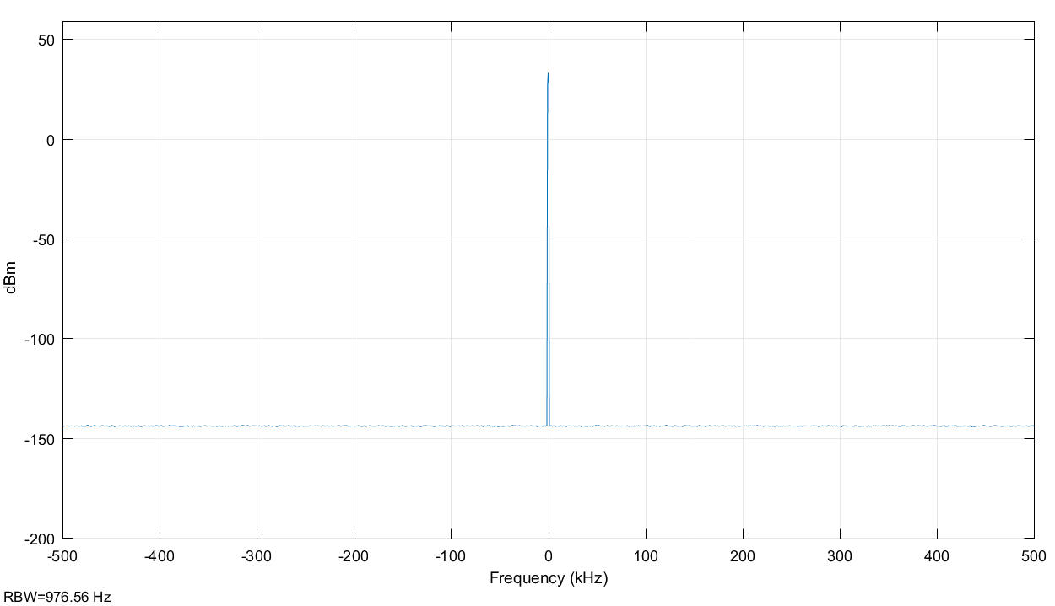

Bandwidth – Because it is a pulse, there is no bandwidth

The bandwidth is the region within most of the signal energy is concentrated.

Q8

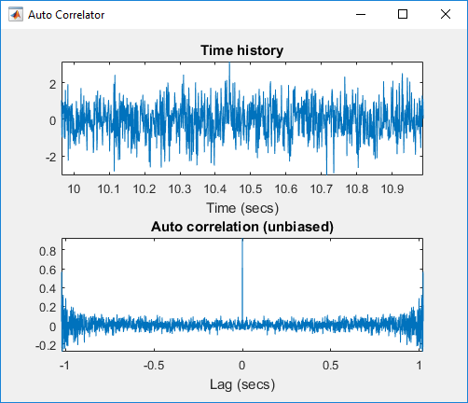

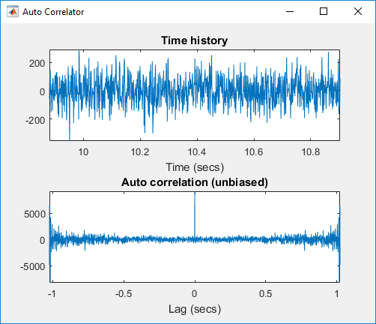

The height of the Auto correlation equal to the value of the variance. For a small variance, the values of the random signal are less spread out, than that of a larger variance.

Part 2

Q1 Sine Wave

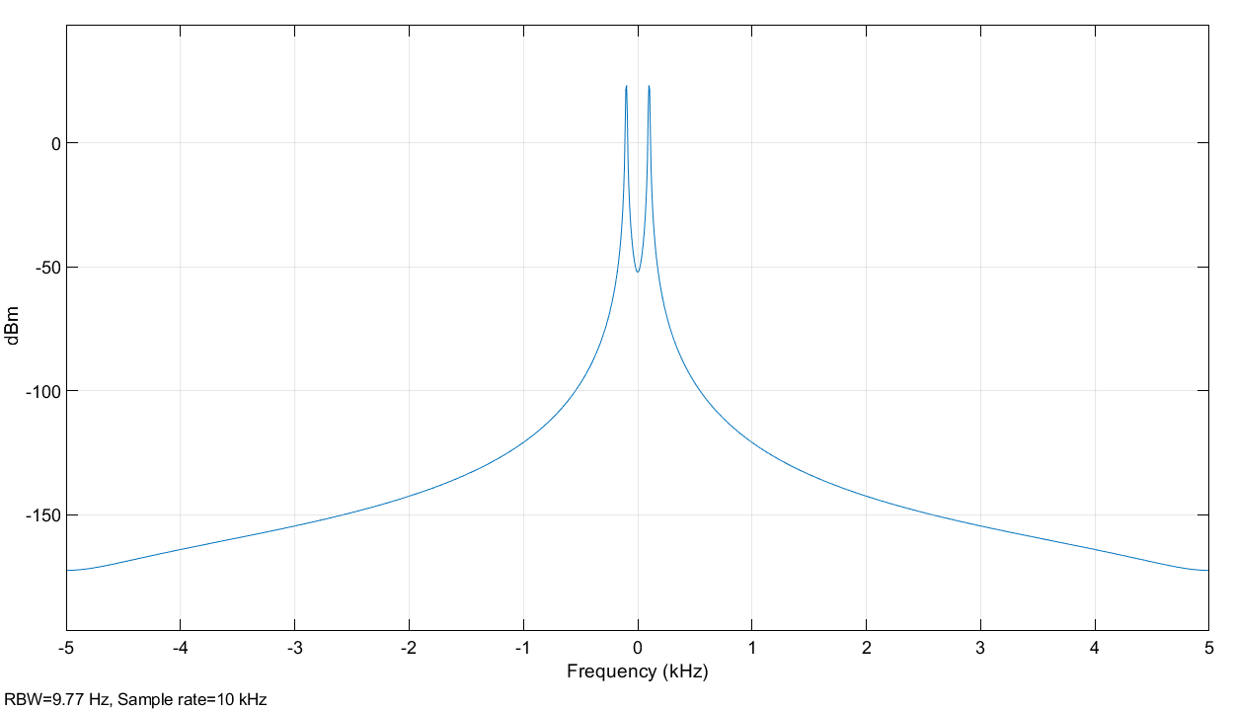

Q2 Triangular Wave

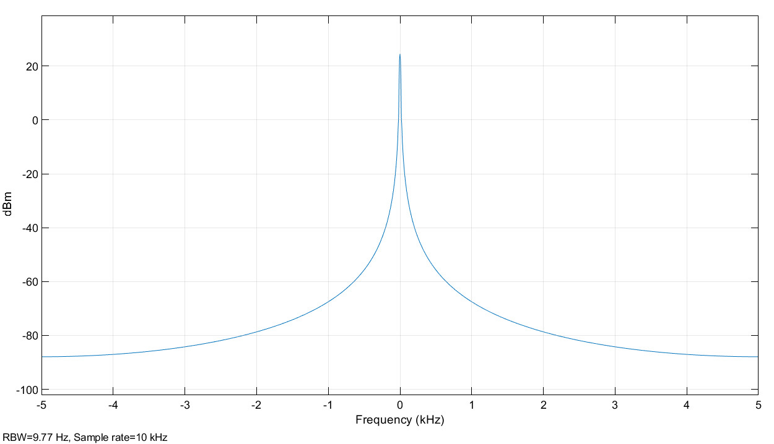

Q3 Pulse Wave 50%

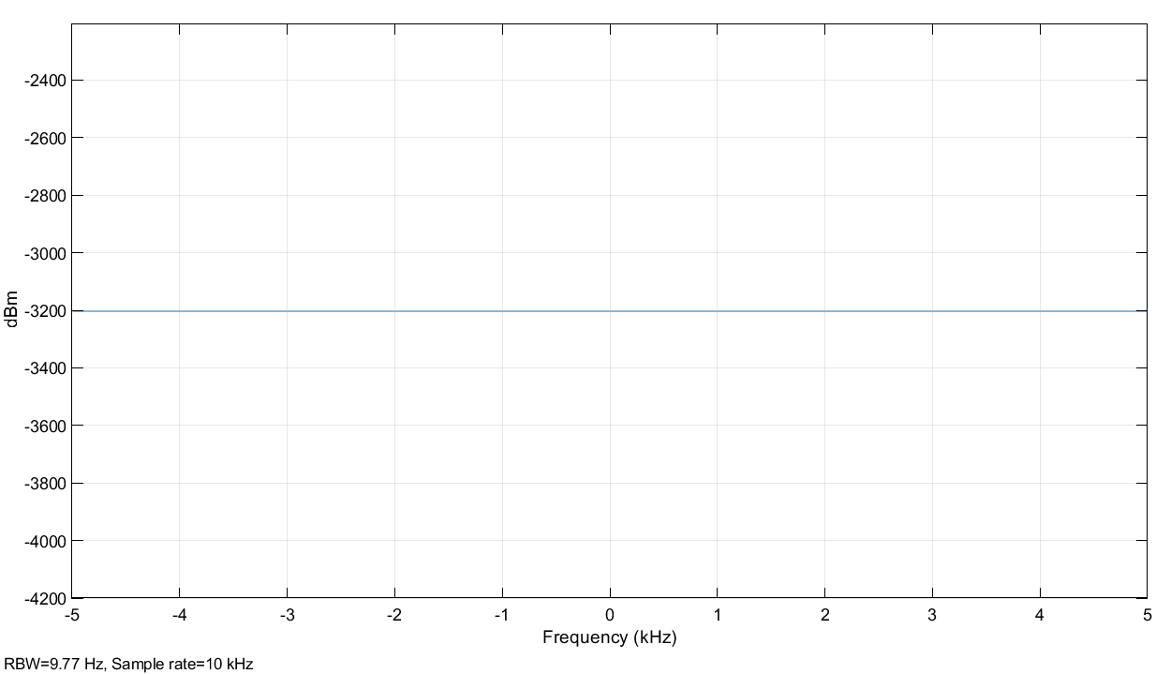

Q4 Pulse Wave 10%



Q5 Sum of Signals, three sine waves

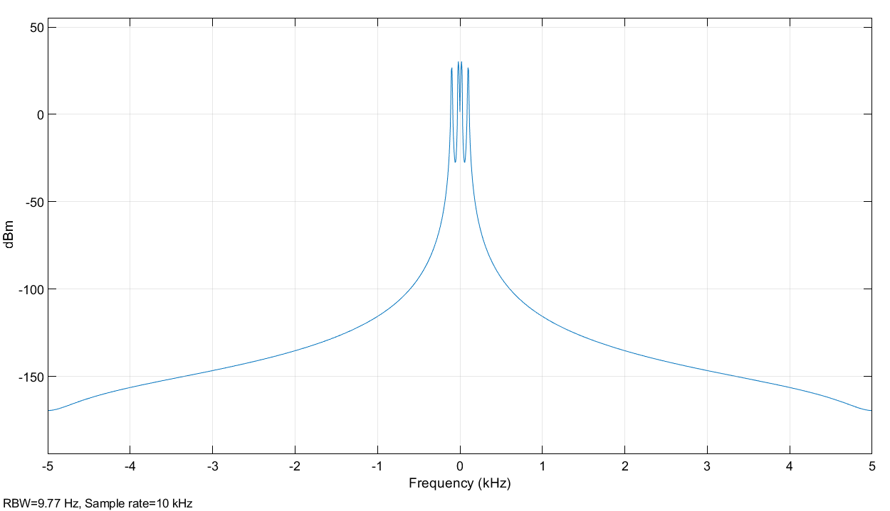

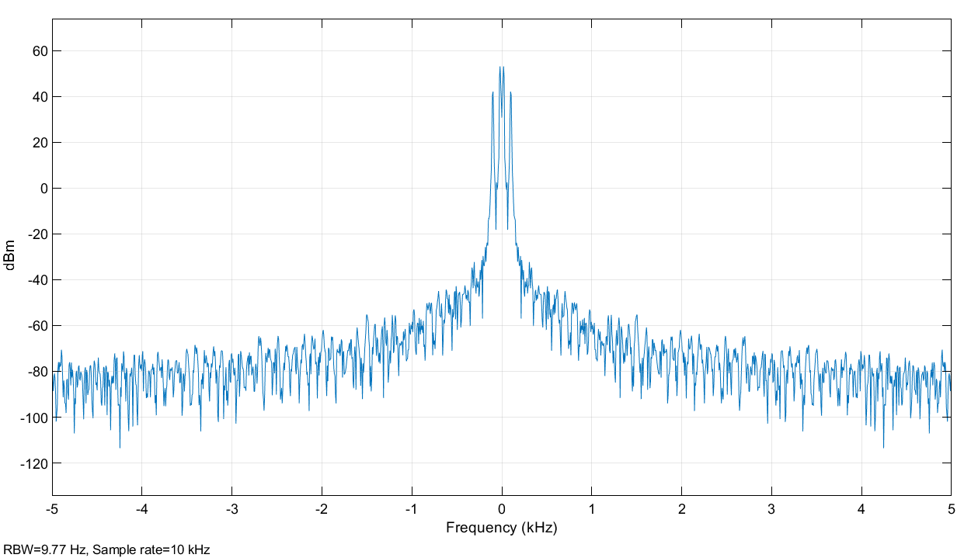

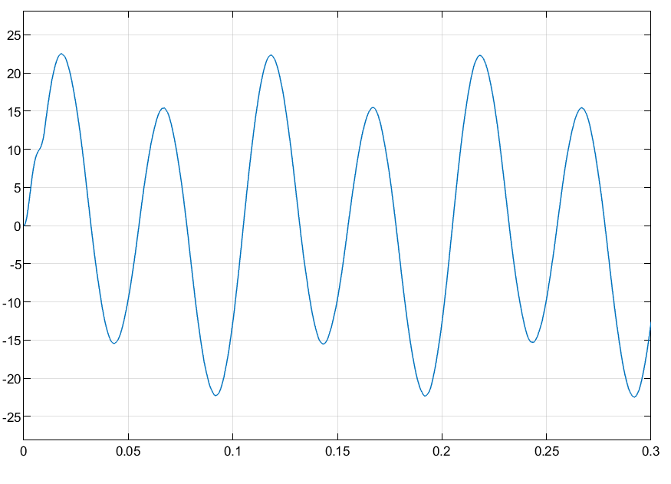

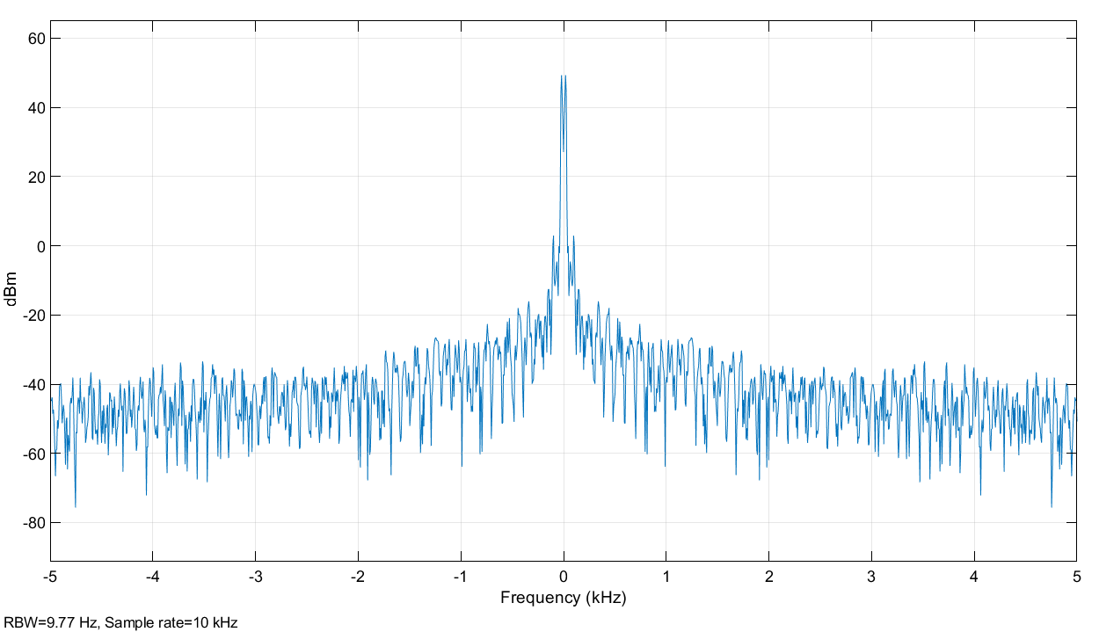

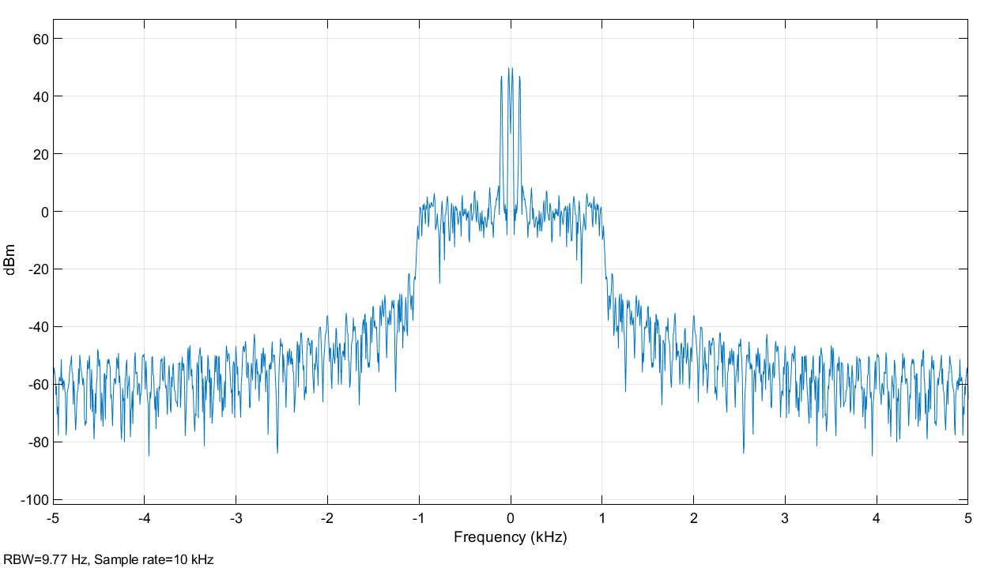

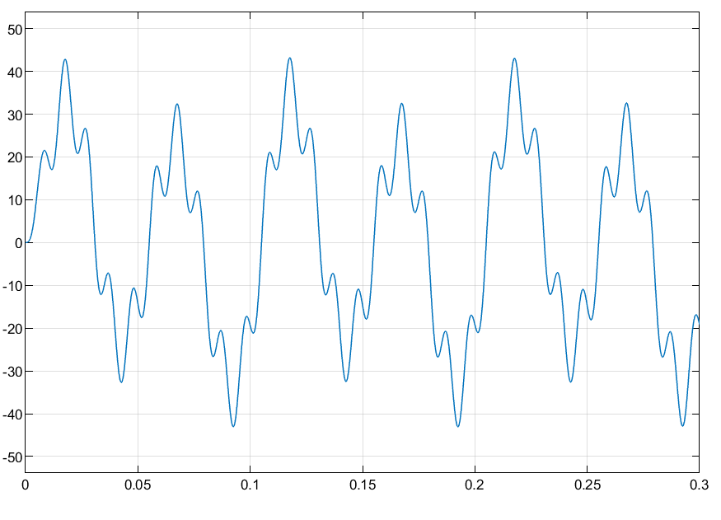



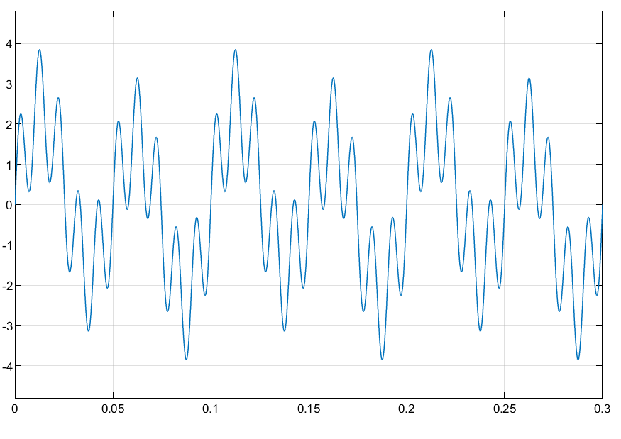

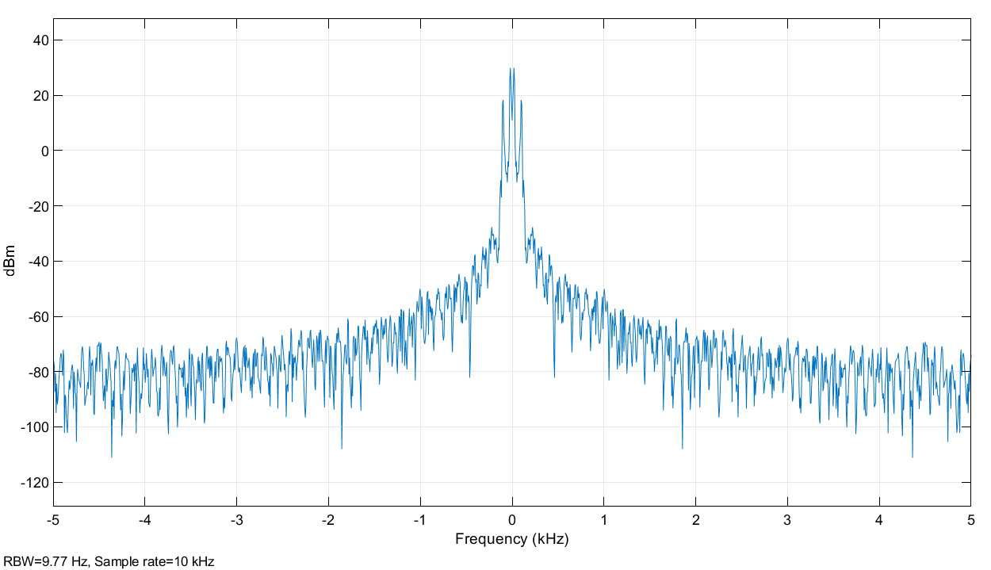

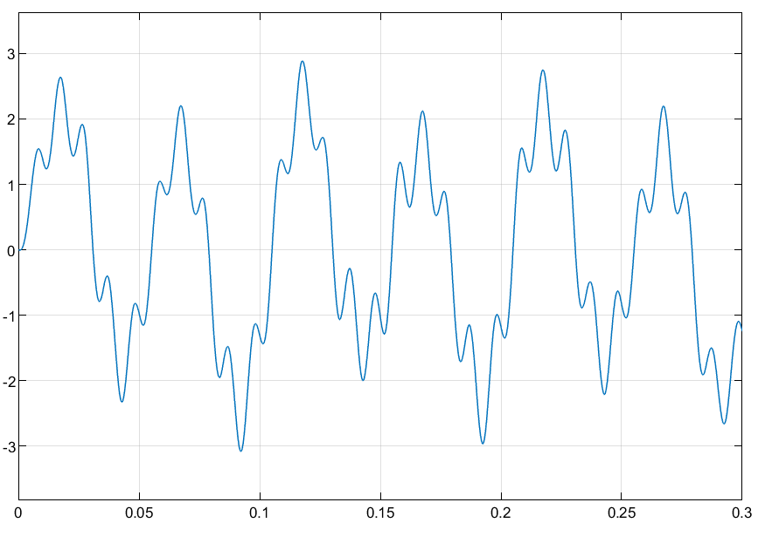

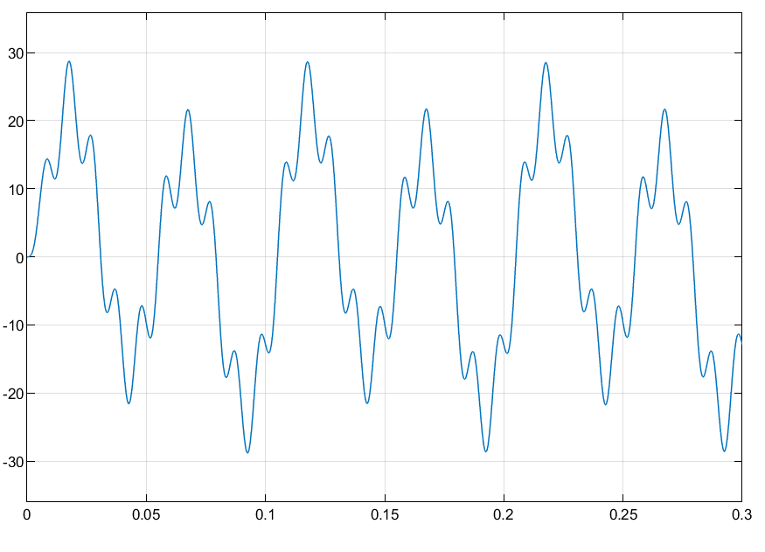

Largest frequency from the three waves: 100Hz

Bandwidth: 200 Hz

Channel Power: 34.842 dBm

6. Outputs on Scope (Rx) and Spectrum (Rx).

Scope Rx

Signal is distorted because of added noise.

Peak value is larger than the input, because of the noise, multiple signals are interfering so we get higher values.

Spectrum Rx

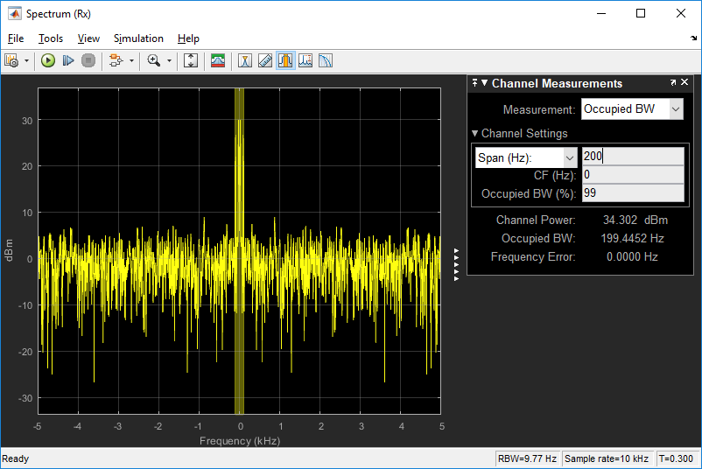

Channel Power: 34.302 dBm

Channel Power is lower, because of noise. Spectrum pattern has changed and does not look similar to that without noise, outside the bandwidth.

7. Compare the outputs on Scope (Filtered) and Spectrum (Filtered) with those on Scope (Rx) and Spectrum (Rx)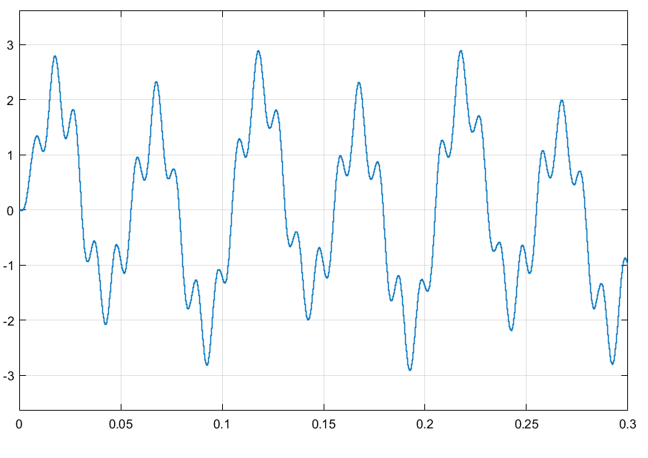

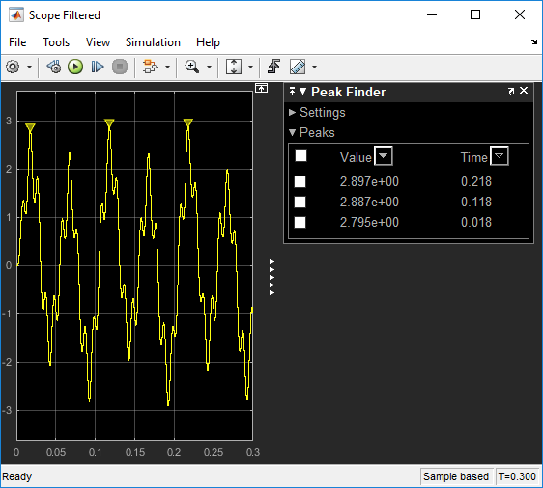

Spectrum Filtered

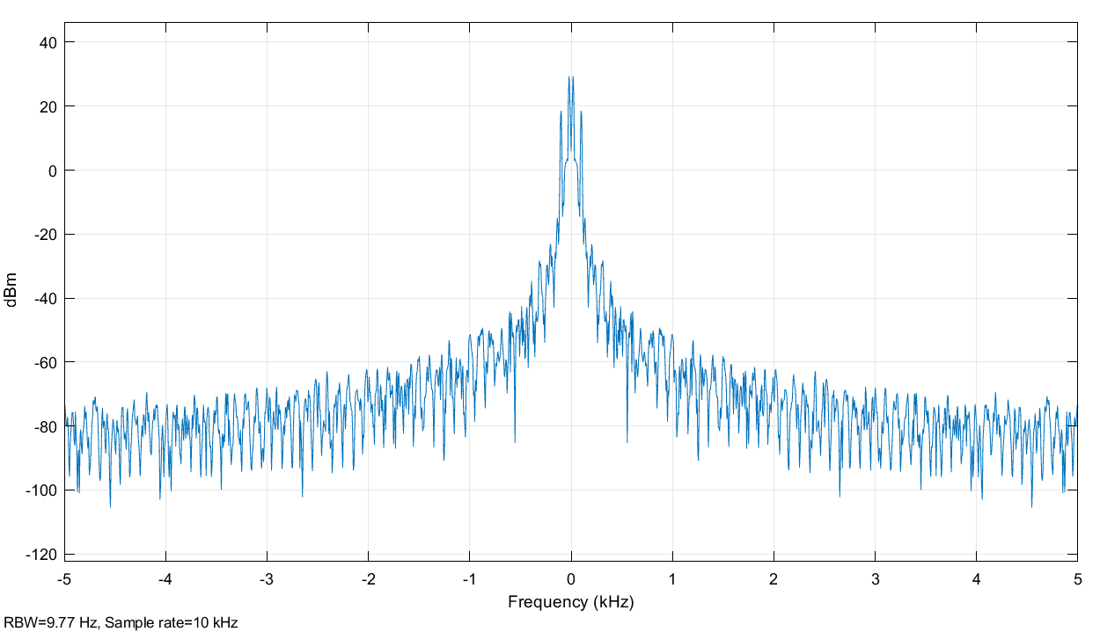

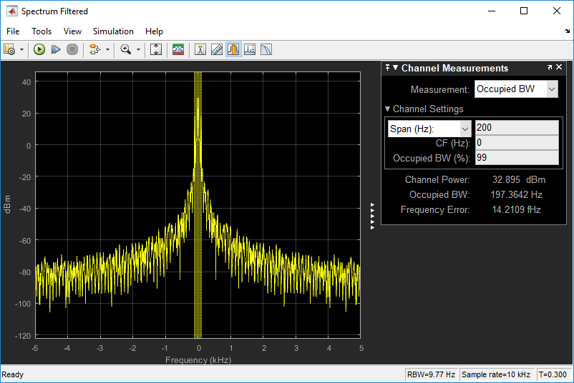

Comparing Scope (filtered) and scope (Rx)

Filtered is a lot smoother, but we loses some data points when filtering it. We can even go further and compare it with the input signals where the amplitude is higher. Thus, we see the loss when it tries to separate the actual wave from the noise.

Spectrum Comparison

Channel Power = 32.895

Channel Power has decreased due to smoothing and averaging. The spectrum pattern has changed and looks similar to that without noise. The variation fluctuates much more.

8. Slider Gain and Digital Filter Design

Slider Gain = 10

Fig: Scope Filtered

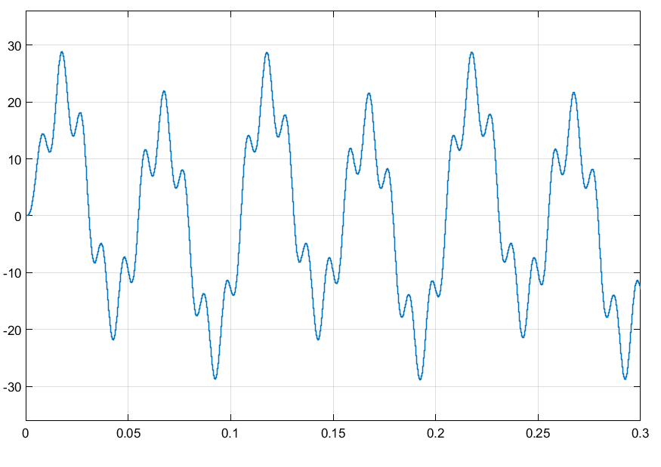

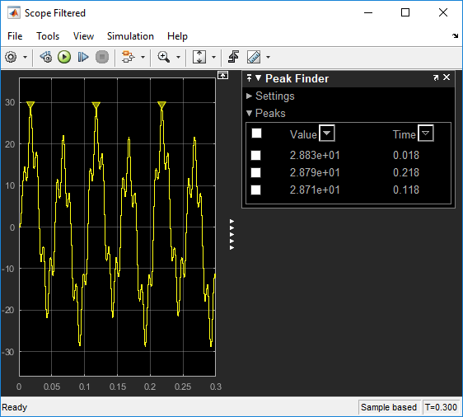

Scope Rx

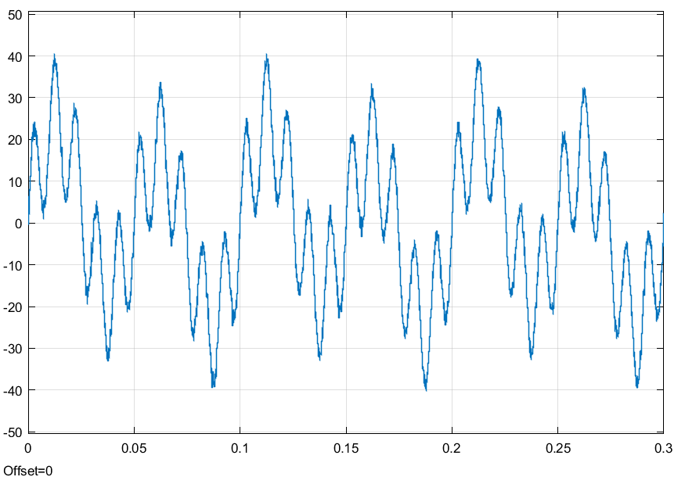

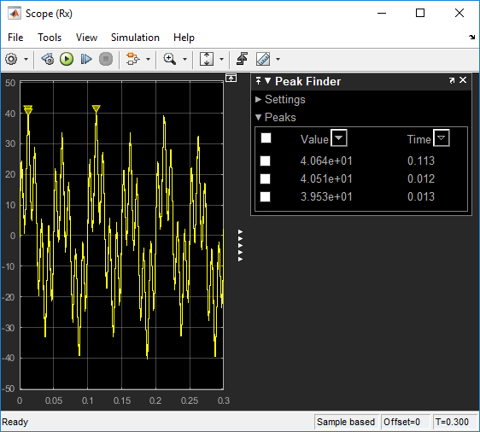

Noise comments -

Spectrum Filtered

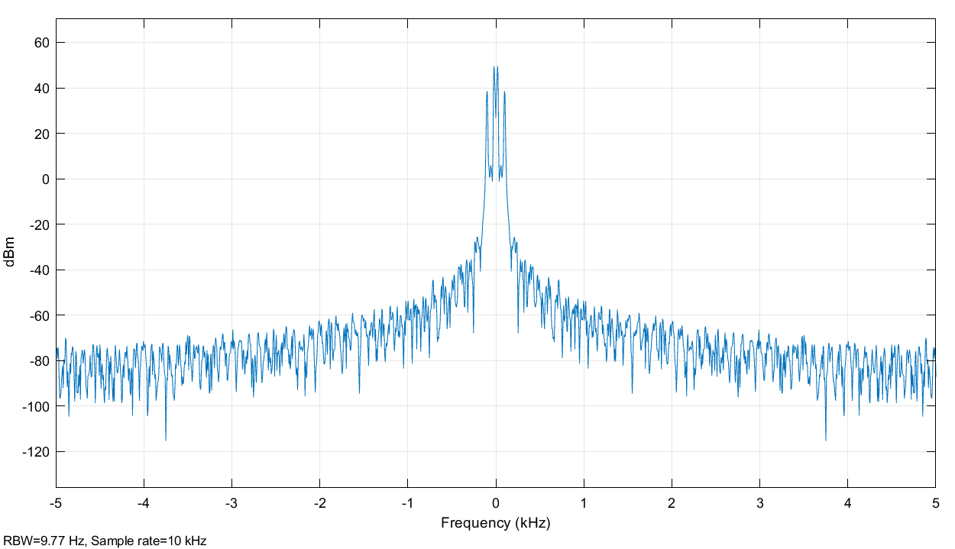

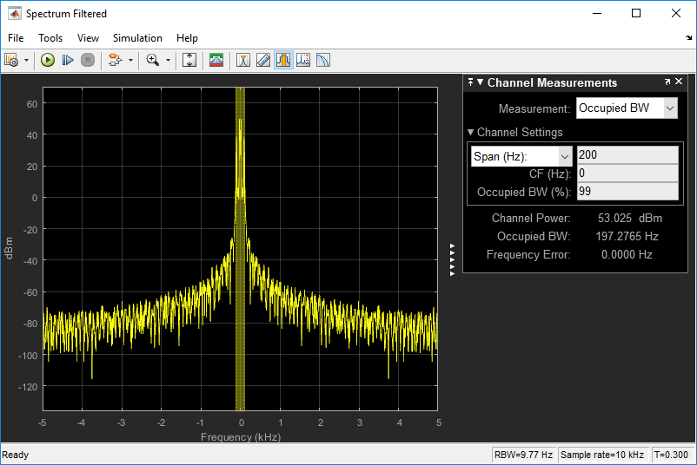

Scope Filtered

cutoff frequency variation for a frequency of 1000Hz.

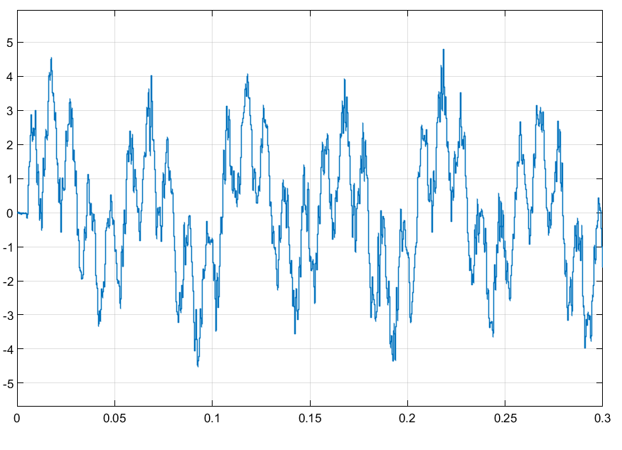

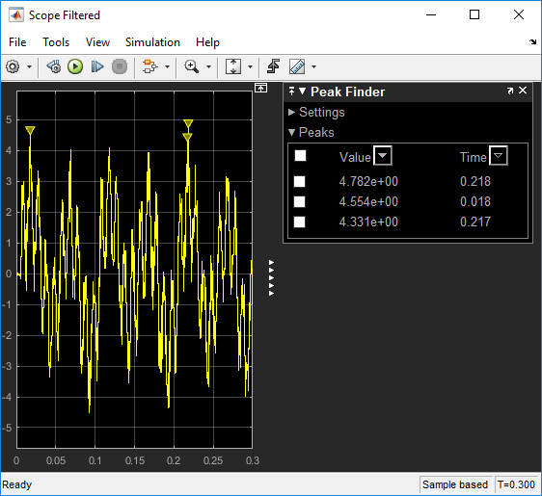

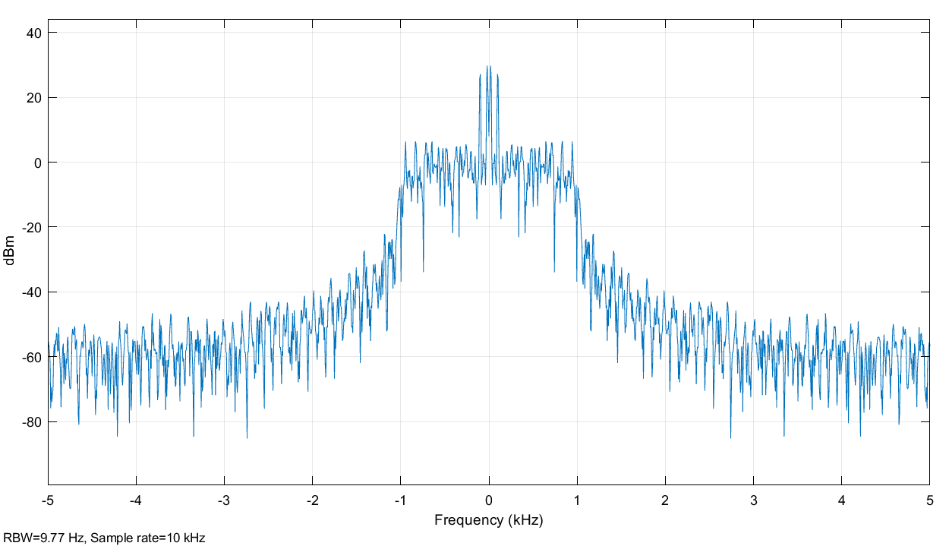

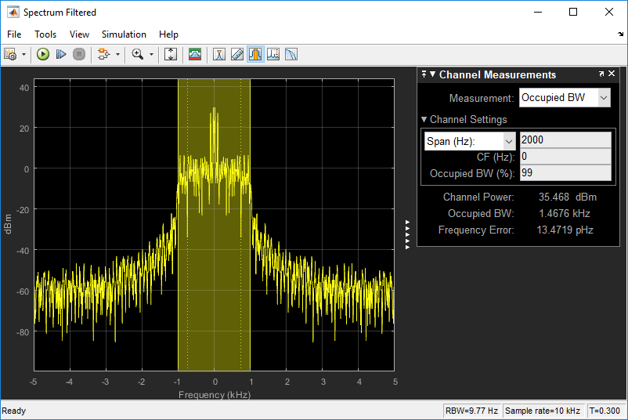

Higher cutoff frequency, give a larger bandwidth, in which the system will function. The drop for the gain depends on the cutoff frequency, low pass.